Collaborative Map Activity
Resources / Things you’ll need:
•A Google account for the teacher (students will NOT need accounts)
•A Google form/spreadsheet to gather the data
http://docs.google.com
•The BatchGeo tool to map the data
http://www.batchgeo.com

Instructions

Creating the Form:
1.Go to http://docs.google.com
2.Pull down the “Create New” button and choose “Form.”
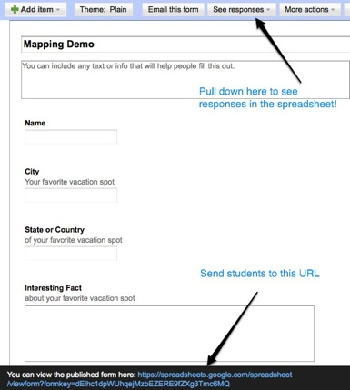
3.Add a title and some questions similar to these:
- Name
- City
- State or Country
- Interesting Fact
Note - You could find out: where students were born; the farthest they’ve ever traveled; their favorite vacation spot; if they could live anywhere in the world; etc.

4.Send students to the blue URL at the bottom of the form-creation page.
Note - You can use TinyUrl.com to shorten the address!
5.Give students time to fill out the form.

Copying the Data:
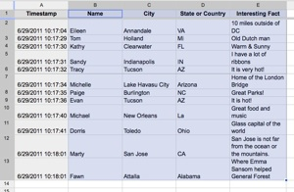
1.Go to the spreadsheet that collected the form data.
- From the form-editor window, pull down the “See Responses” button and choose “Spreadsheet.”
OR
- Go to the Google Docs homepage (docs.google.com) and click the link with the title of your form.
2.Click and drag to select the data (including the column headers).
3.Copy the selected data.
- Control + C (Win)
- Command + C (Mac)

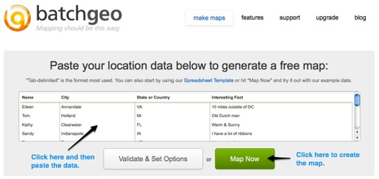
Creating the Map:
1.Go to BatchGeo.
http://www.batchgeo.com
2.Paste the data into the provided area.
- Control + V (Win)
- Command + V (Mac)
3.Click the “Map Now” button.

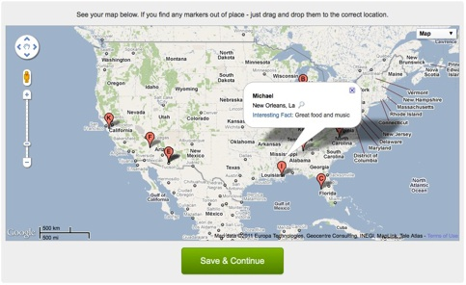
4. Click a placemark on the map to reveal the student’s name and interesting fact.
5.Click the Save & Continue button. (Optional)
6.Enter a name for your map and enter your email address. (Optional)
7.You will receive an email that contains a URL and embed code for your map. Then you can easily share it with others! (Optional)

